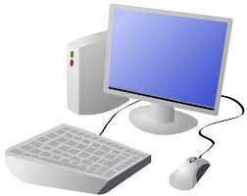
COMPUTING: CREATING MEDIA- Video Editing
KNOWLEDGE ORGANISER
Y5

Overview |  |  |  | Editing Videos
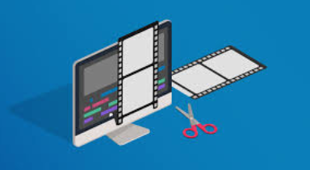  Video Editing  -You should already know that video means the recording, reproducing and broadcasting of visual images (often accompanied by audio).  -Video is made up of a sequence of images shown in quick succession, giving the impression of movement.  -Many different devices can be used to record, edit and playback video and sound.  -Theme, setting, characters, colour, sound, and dialogue are all important features of video.  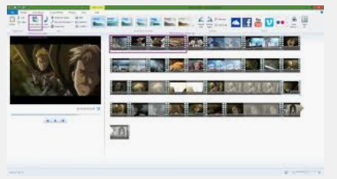 |  |  |  | Windows Movie Maker is one example of a video editing tool, but many others are available. Examples include WeVideo, Nero Video, and Apple iMovie.
 |  |  |  |   In order to edit your video, you first need to import it from your device to the computer. You then need to import it into Movie Maker by clicking ‘Add videos and photos.’ | 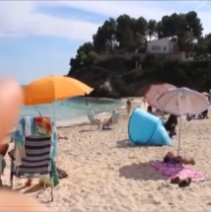  By right-clicking on the video thumbnail, you can choose to ‘split’ the video into pieces. The different pieces can be moved or deleted.  A number of special effects are available, including using animations and transitions between shots. You can also add text in captions.  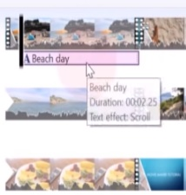
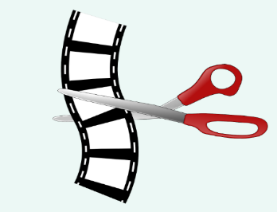
The trim tool allows you to move excess video from the beginning or the end.

Features of Videos |  |  |  |   Remember to save your project regularly. You need to save your project as a *.wmv file so that you can continue to edit it.
Videos present moving images, often accompanied by sound. The following features are commonly found in videos.
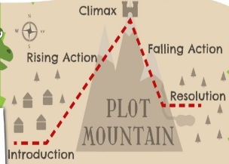  Plot means the main events in the video, shown in a sequence. Plot features are caused by and affect one another. | 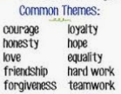  Themes are the main ideas that run through the video, e.g. love, friendship, magic, violence. |  |  | Recording Videos
 |  |  |  | 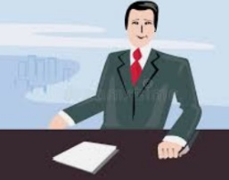  Zooming: Zooming in means to give a closer view of the subject. Zooming out gives us a further, broader view of the subject. Zooming too close can make the subject appear blurry. |  | Top Tips for Recording High-Quality Videos  -Use considered lighting.  -Think carefully about the sounds that you will use, e.g. music and sound effects.  -Think about the use of colour.  -Consider the use of a green screen for settings.  Devices for recording video:  iPads/tablets/smartphones  Camcorders or Cameras  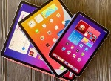  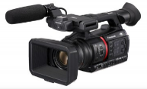
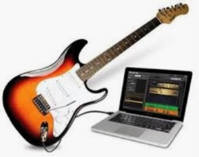  Most videos, even very short videos, try to give the audience a message. This may be obvious or hidden. | 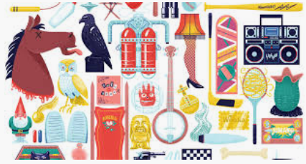 |  | Props are the moveable objects that are used by the actors/ actresses in videos texts. | 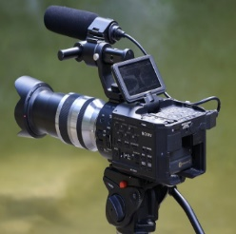  Static Camera: The camera is in a fixed position, sometimes using a stand or tripod. Examples of this in use are during news-reading and weather forecasts.
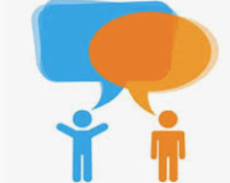  Dialogue is the name given for the conversations between people in video texts. |   Characters are the different people and animals in a story, including in a video. |  |  | 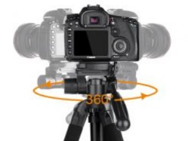  Pan: The camera position is fixed, but moves from side to side.  Tilt: The camera position is fixed, but moves up and down.

Important Vocabulary
Video Audio Recording Storyboard Script Soundtrack Dialogue Capture Zoom AV (Audio Visual) Videographer Zoom Pan Tilt Angle Lighting Setting Export Split Trim/Clip Titles Timeline Transitions Content Retake Special Effects Title Screen End Credits

