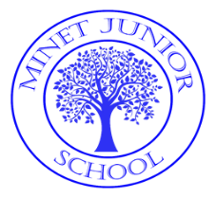
Progression in Guided Writing

Year 3 | Year 4 | Year 5 | Year 6
Each lesson of guided writing contains 3 points of SPaG which are taught and applied in each ‘chunk’ of writing.  Each daily guided write presents a section of the modelled genre which are presented as plot points for narratives and shapes for non- fiction. Narrative  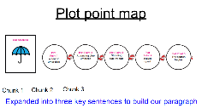  E.g  Pupils are presented with 3 modelled sentences – one per chunk. Pupils are taught the meaning of colour coded words and phrases:  Red – very important punctuation  Blue – teaching point (change words)  Black – these words stay the same  Green – these words can change if desired  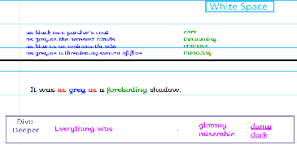  Pupils are provided with word banks to  enable them to change words within each  sentence and to build upon their  understanding of sentence structures. The  teacher models the new sentence using  input from the children after which they write their own examples.  ‘Dive deepers’ are in place and provide  Additional challenge as required. | Each lesson of guided writing contains 3 points of SPaG which are taught and applied in each ‘chunk’ of writing.  Each daily guided write presents a section of the modelled genre which are presented as plot points for narratives and shapes for non- fiction. Biography  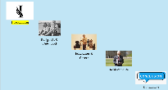  E.g  Pupils are presented with each  chunk of modelled writing and emphasis is placed on key words and phrases that are written in blue and have to be replaced whilst still maintaining accuracy in meaning and sentence structures :  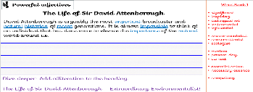  Pupils use white boards to practice their writing and the teacher models an alternative version on the IWB.  Edit and improve is modelled by the teacher.  ‘Dive deepers’ are in place for each chunk to extend and develop the writing process. | Each lesson of guided writing contains 3 points of SPaG which are taught and applied in each ‘chunk’ of writing.  Each daily guided write presents a section of the modelled genre which are presented as plot points for narratives and shapes for non- fiction.  Narrative  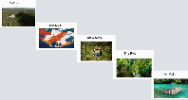  E.g  Pupils are presented with each chunk of modelled writing. They discuss alternative vocabulary, which is available in word banks, focus punctuation and sentence structures:  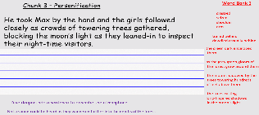  MAPs are given thesauruses to collect vocabulary and add to the word banks.  Pupils use white boards to construct sentences and try out their ideas.  The teacher uses the children’s ideas and models an alternative text on the IWB. Pupils then construct their own example independently.  Edit and improve is modelled by the teacher.  ‘Dive deepers’ are in place for each chunk to extend and develop the writing process. | Each lesson of guided writing contains 3 points of SPaG which are taught and applied in each ‘chunk’ of writing.  Each daily guided write is used as a build up to the focus genre rather than a modelled example of the genre itself.  For example: Narrative  Day 1 – Setting description  Day 2 – Characterisation  Day 3 – Dialogue  Day 4 – Cohesion  Day 5 – Cliff hangers  Vocabulary banks are provided on the IWB. Persuasive Letter  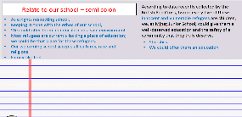  E.g  Pupils are also given thesauruses to collect own vocabulary.  Pupils are presented with a WAGOLL for each example text and are then guided by the teacher to construct another version of the text. Pupils use white boards to try out their ideas.  Pupils then construct their own example independently.  Pupils edit and improve daily.  ‘Dive deepers’ are in place for each chunk to extend and develop the writing process.
-

