Minet Junior School



Handwriting Policy 2023

Up-dated by
S Moxon
(English Co-ordinator)

Handwriting Policy and Guidelines

Aims
For all children to:
- Develop a handwriting style, which is legible, fluent, joined and neat.
- Be able to adapt their handwriting style according to the purpose of the writing task.
- Develop their individual handwriting styles.

Objectives
In order to achieve the above aims we will:
- Provide frequent and regular opportunities to learn, practise and develop handwriting skills.
- Ensure the presentation of work and quality of handwriting has a high profile throughout the school.

The role of staff
Demonstration by the teacher in cursive writing is an essential element, followed by observation as children practise and intervention with support or praise as appropriate by teachers and teaching assistants.
Bad habits are difficult to correct later, it is important to observe carefully, identify any difficulties and intervene to correct them.
- Handwriting and presentation are of a high priority and correction of the formation of letters and writing on an individual/group basis should be made in literacy and across the curriculum.
- Handwriting practice must be done frequently. To raise handwriting skills, work can be provided for practice at home with adult support.
- Every effort should be made to identify significant difficulties as early as possible to prevent them further becoming bad habits.
Common faults:
Incorrect or awkward pencil/pen grip
Poor posture and paper positioning
Incorrect letter formation and join
Inconsistent size of writing
Misuse of lower and upper-case letter
Joining upper case letters
Possible reversals/inversions
Lack of care with, and pride in presentation
- Handwriting should be taught in conjunction with spelling by the use of letter strings and phonics.
- Spellings can be reinforced through writing practice.
- Suitably lined paper or books with centre lines for lower case letters, and space for ascenders and descenders is appropriate for practice in year 3, for those whose handwriting needs improvement and for children who are experiencing handwriting in English for the first time.
- Wider spaced lines offer room to practice forming joined letters correctly and maintaining proportion before reducing the size of the writing.
- Spaces between words can be judged by using the width of the little finger on the non-writing hand as a measure.
- Worksheets, display titles and labels, must be hand-written or word processed in a cursive style, using templates or a suitable font, to reinforce the joined formation of letters and careful presentation.

Equipment / Resources
Teachers to make use of the following website to support the teaching of handwriting. https://www.debbiehepplewhitehandwriting.com/free_resources.html
When pupils are confident and cursive writing is of a good standard they will be given a pen by the school. After this, pupils will purchase their own pens. Once a pupil can write with increasing fluency they will be awarded a ‘pen license.’
Children will always use pencil for mathematics.

Progression in Key Stage Two

Year 3
Dedicated handwriting sessions are very important, alongside providing regular opportunities to use skills in all tasks and extended writing.
All letters should begin on the line and entry and exit strokes should be apparent.

Year 4
In year 4 children should be confident users of joined script; more fluent writers should begin developing their own style in their handwriting. Children should be taught to distinguish between writing tasks i.e., those that demand a higher level of presentation and those that require greater speed.

National Curriculum 2014 - Lower Key Stage Two – Years 3 and 4
Joined handwriting should be the norm; pupils should be able to use it fast enough to keep pace with what they want to say.

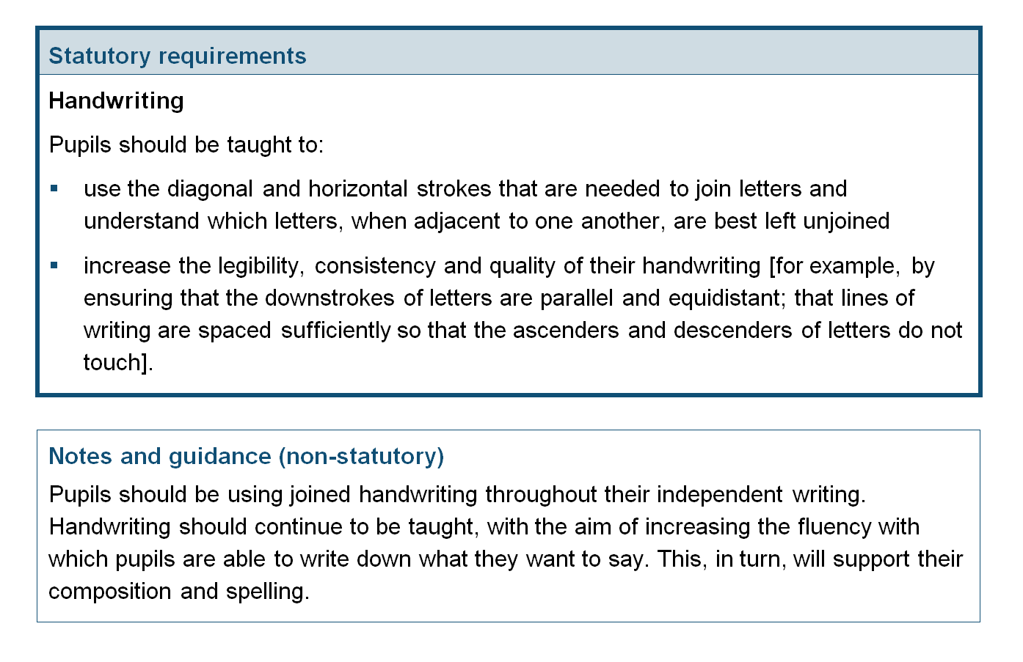

Year 5 and 6
Children should be encouraged to refine and improve their fluent, joined and legible handwriting.
They should continue to be given regular opportunities to practise and improve their handwriting through dedicated handwriting sessions, e.g. in unhurried opportunities for final best copies of independent writing. When pupils have not mastered letter formation and joins, interventions should be in place to correct errors and improve handwriting skills.

National Curriculum 2014 - Upper Key Stage Two – Years 5 and 6
Pupils should be able to write down their ideas quickly.


