Minet Junior School

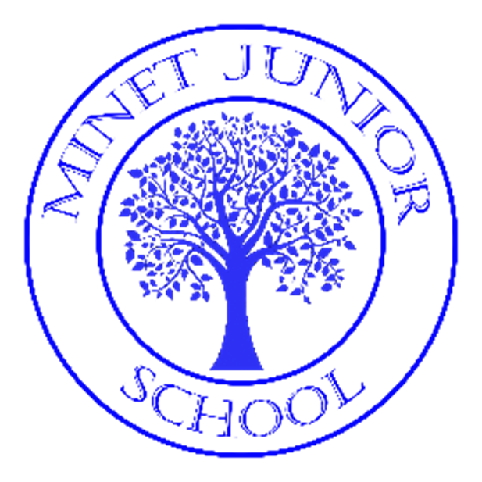

Writing Policy 2024

Up-dated by
Sue Moxon

A Policy for the Strategic Approach to the Teaching of Writing

Rights Respecting
The policy has been composed with due consideration to our whole school commitment to the Rights of the Child and our accomplishment of being a Rights Respecting School. It is written in accordance with Article 28 of the United Nations Convention on the Rights of the Child ‘Every child has the right to an education’ as well as Article 29 ‘Education must develop every child’s personality, talents and abilities to the full.’ Although direct reference to this is not continuously made, the policy has been written with full consciousness of our responsibility and commitment to pupil’s rights.

What is our intent?
At Minet Junior School we believe that the ability to write is a life – long skill which is fundamental to our pupils’ success. Our curriculum has been developed to foster a passion and enthusiasm for writing for a variety of audiences and purposes. We recognise the importance of nurturing a culture where children take pride in their writing and can adapt their language and style for a range of contexts.
Our intent is to enable children to:
- Write clearly, accurately and coherently whilst taking pride in the work that they produce.
- Acquire a wide vocabulary to use creatively and appropriately.
- Confidently use the essential skills of grammar, punctuation and spelling.
- Enable pupils to express themselves confidently and to articulate their understanding and ideas clearly.
- Re-read, edit and improve their own writing.
- Develop a neat, cursive handwriting style.
How is it implemented?
English lessons are taught daily across the school and to the whole class, therefore allowing all children to have access to the age-related skills and knowledge contained in the National Curriculum.

As a school, our English curriculum is supported by the pedagogy of both ‘The Power of Reading’ and ‘The Write Stuff’. Key texts have been carefully selected for all year groups to be representative of the pupils, challenging and in line with the long- term cross – curricular progression map throughout the school. Each year group have a yearly overview of the writing topics, both narrative and non-fiction. These have been planned to ensure coverage of the key genres as well as build on skills from year to year. The outcome of each unit will be a piece of writing which will be used to assess the pupil’s skills against the Key Performance Indicators for their year.

Each year group studies two high-quality texts every half term which offers children engaging and challenging English lessons. Within each unit of work, children are given opportunities to participate in drama, spoken language activities and writing for a variety of purposes. Opportunities are planned for children to use knowledge from other subjects within their English writing and vice versa.

At Minet Junior School progressive writing skills and techniques are taught using a highly structured approach, which are supported by unit plans. By using high – quality texts, children engage in meaningful discussions, learn key vocabulary, understand grammar and punctuation skills and are inspired to write creatively.

The key aspects include:
- Building pupils’ confidence with sentence structure.
- Pupil’s vocabulary is widened and extended.
- Widening the repertoire of writing options for pupils.
- Pupils gain an understanding of the ‘whole’ piece that they are writing.
- Organisation of their ideas and cohesion between them is strengthened.

Our English Curriculum provides a structured approach to spelling by teaching children a range of techniques, allowing them to learn about word origins and to identify spelling rules. Children are encouraged to apply their phonetic knowledge to learn new words. Pupils are taught the statutory spelling words from the National Curriculum in the context of their learning.

We pride ourselves at Minet Junior School with the high expectations we have of the children in handwriting and presentation. Children learn correct letter formation and a joined cursive script. Teachers reinforce the school’s handwriting style when marking children’s work, writing on the board and on displays around the school.

Planning and Progression
The National Curriculum programmes of study for writing at Key Stage 2 consist of two dimensions:
• transcription (spelling and handwriting)
• composition (articulating ideas and structuring them in speech and writing).
Our curriculum is structured so that teaching develops pupils’ competence in these two dimensions with clear progression across the year groups. In addition, pupils are taught explicitly how to plan, revise and evaluate their writing. The curriculum is planned to ensure a wide range of literature from different cultures and heritages is explored and valued. Our curriculum has been designed to best suit the needs of our pupils and to spark interest, challenge and curiosity.

At Minet Junior School, reading and writing are closely linked. We use a variety of high -quality core texts to form the background of reading and writing. These texts also act as a stimulus for the wider curriculum. ‘The Power of Reading’ initiative enables teachers to take advantage of opportunities to make cross-curricular links. They will plan for pupils to practise and apply their writing skills, knowledge and understanding acquired through English lessons to other areas of the curriculum.

Our medium- term planning is based on a series of 3 - week units which use the following structure:
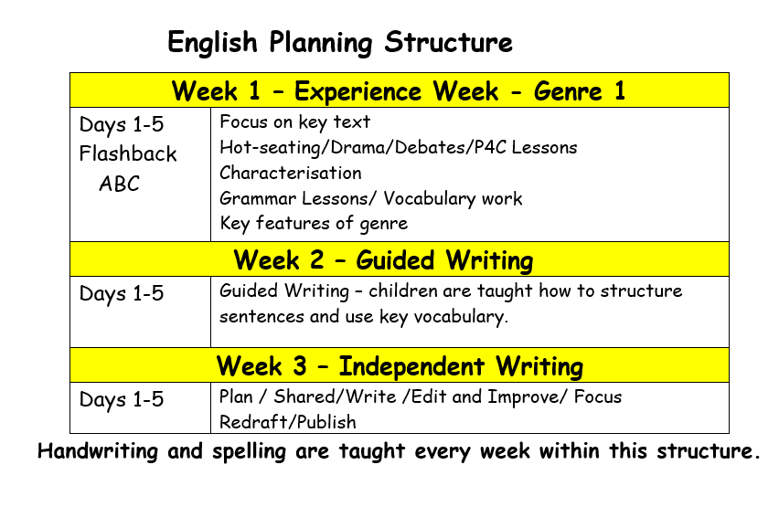

Teaching and Learning
At Minet Junior School, children have daily English lessons. Spelling and Grammar skills are taught both discretely and embedded within English lessons. The reading aloud of a class novel, which is a text linked to their current topic learning, is done on a regular basis. We aim to develop the children’s ability to produce well structured, detailed writing in which meaning is made clear and which engages the interest of the reader. High priority is given to teaching the formal structures of English, grammatical detail, punctuation and spelling. All classrooms have a ‘working wall’ where shared/guided writing, vocabulary and information to support learning are displayed.

Oracy:
We are committed to building and embedding a culture of oracy. Purposeful talk is used to drive forward learning, through talk in the classroom, which has been planned, designed, modelled, scaffolded and structured to enable all learners to develop the skills needed to talk effectively and with confidence. The deliberate, explicit and systematic teaching of oracy across throughout the English curriculum will support children to make progress in the four strands of oracy. We want every child at Minet Junior School to find their voice.

Experience Week:
This involves immersive teaching to enrich our children, develop oracy, vocabulary and stimulate ideas. These can take many forms (visits out, visitors in, special curriculum days,
P4C lessons, related film/video clips, drama conventions etc.) and are deployed to strengthen context and build imagination. The ‘flashback ABC’ starters, reinforce sentences structures during these lessons.
‘The Power of Reading’ initiative helps pupils to develop a rich vocabulary through discussion, immersion into the language of the text and role play. Reading teaching strategies that support the development of oracy skills include:
- responding to illustration
- role on the wall
- freeze-framing
- poetry
- conscience alley
- hot seating
- role playing
- jigsawing
- performing

Guided Writing:
At Key Stage 2 (Years 3-6) children are taught to change the way they write to suit different situations, purposes and audiences. Using high quality texts, they explore the use of language in fiction and non-fiction texts and learn how the structure of language works (using grammatical terminology).
Writing is fundamental to our children’s ability to express themselves. Our emphasis is on teaching skills that increase the children’s ability to:
- Recognise purpose and organisation of styles of writing and use them appropriately
- Write fluently and accurately, with understanding and enjoyment.
Pupils experience frequent opportunities to write in different contexts, subjects and formats for a variety of reasons and audiences.

When teaching guided writing we have a developed an approach to our teaching and learning to ensure clarity to the mechanics of writing and that our pupils develop a rich and varied vocabulary across a range of contexts. Following a method called ‘Sentence Stacking’, this approach places emphasis on sentences being ‘stacked together’ chronologically and organised to engage children with short, intensive moments of learning that they can then immediately apply to their own writing.

Within each genre studied by the children, they will learn to sentence stack, focusing on the style of the author and the impact of vocabulary and sentences most appropriate for that particular genre.

During each lesson, writing is ‘chunked’ into three distinct parts, focusing on specific sentence structures, vocabulary and grammar points to support the writing process. Alternative vocabulary is shared with pupils and the teacher models how to create a new version of the text using children’s ideas to demonstrate the thoughts and processes of a writer whilst articulating writing choices. Pupils are encouraged to use their own word choices and thesauruses to extend their engagement in the learning process. The teacher will also model edit and improve skills at the end of each ‘chunk’. Following this, pupils are given the opportunity to create their own ‘chunk’ applying the modelled strategies and using vocabulary banks. Children are challenged to ‘dive deeper’ which requires them to draw upon previously learnt skills.

Independent Writing:
During this part of the sequence, teachers use a shared writing approach to demonstrate strategies to support pupils in their independent writing. Children are taught how to edit and improve and are given opportunities to draft and redraft their writing. Pupils use success ladders to identify what they have done well and what they should do next to improve the quality of their writing so that they are fully engaged in the acquisition of knowledge and skills. Oracy work from the experience week is used to support the improvement of children’s writing. Pupils are encouraged to ‘read as writers’ and explore the creative process involved in generating and planning ideas and incorporating techniques learned from other writers into their own work. Pupils a rehearse the structure and sequence of their writing as well as appropriate language and grammar as they to plan, draft and improve their writing.

Spelling
We teach spellings through the use of spelling patterns alongside the spelling lists for years 3/4 and 5/6 in the National Curriculum. The children are taught the spelling pattern through- out the week. These spellings are sent home to practise and learn. At the end of the week, the children are tested on their spellings and this score is recorded. Children are encouraged to use and apply these patterns in their independent writing.

Phonics
Explicit phonics teaching continues into Key Stage 2, and for as long as necessary, for pupils who require extra support and learning time to focus on securing their phonetic knowledge. This is taught through Read, Write, Inc.

Mastery
Effective mastery in English reflects independent learning which demonstrates creativity, imagination and innovation across a range of genres. Using a range of high- quality key texts as a stimulus allows children to look at how writers use language and words to impact on the reader and use them as models for their own writing. Precise questioning during lessons, including a variety of different question types, ensures that pupils can think deeply about a text or area of focus. Time is given to explore words, develop phrases, play with sentences and paragraphs, meaning that children always consider the impact on the reader when they write and justify their choices. Less emphasis is made on covering vast quantities of text types in each year group, ensuring children develop greater depth and are secure in a range of genres. Grammar, punctuation and spelling are taught explicitly and in context across the curriculum. When pupils are working at greater depth, they can apply the skill confidently, accurately and effectively in a range of writing. The use of high- quality texts also promotes a love of literacy.

Inclusion
We aim to provide for all children so that they achieve as highly as they can in English according to their individual abilities. We identify which pupils or groups of pupils are under-achieving and take steps to improve their attainment in liaison with the SENDCo. Provision is made for children who require extra support through targeted teaching; intervention programmes (e.g. Read, Write, Inc, Fresh Start). Teaching Assistants also support identified pupils to access the English Curriculum during lessons.
Gifted children will be identified in consultation with the G&T leader and suitable learning challenges are provided.

Equal Opportunities
Minet has universal ambitions for every child, whatever their background or circumstance. Children learn and thrive when they are healthy, safe and engaged.
In order to engage all children, cultural diversity, home languages, gender and religious beliefs are celebrated. Our curriculum includes a wide range of texts and other resources which represent the diversity and backgrounds of all our children.
We believe in ‘valuing what the child brings to school’ and recognise the importance of supporting a child’s first language, not only to foster self-esteem, but to assist in the learning of English.

SMSC
Social – Through peer marking children are given the opportunities to comment and debate each other’s work. Talk partners encourage discussion and stimulus for writing. Encouraging children to recognise and respect social differences and similarities.
Moral – providing literature which leads to opportunities to discuss ‘right and wrong’. Learning ‘hooks’ to allow children opportunities to consider different perspectives. Developing an open and safe learning environment in which pupils express their views and practise moral decision making.
Spiritual – Exposing the children to a wide genre of texts, ensuring opportunities to link to the ‘audience’ and ‘purpose’ of writing. Encouraging children to be tolerant of the views and beliefs of others.
Cultural – ensuring children are given opportunities to share their experiences. Writing ‘hooks’ enable children to explore different cultures and make comparisons.

Marking (see Feedback and Marking Policy)
As a school we value both verbal and written feedback in moving learning forwards. All books are marked daily and next step marking should occur a minimum of twice per week in English. All written comments and corrections made by teachers are in PURPLE and follow the school writing codes.
Children then have the opportunity the following lesson to improve the work they completed in accordance to the improvements that have been indicated or the next step comments given by the teacher (Fix-it time, 5 minutes daily).
Children are encouraged to both peer and self-assess their work regularly throughout each taught unit. This enables pupils to edit and improve their own work and also to help each other through constructive dialogue. Pupils are required to use GREEN for self-assessment and PINK for peer- assessment.

Parental Engagement
Parents are encouraged to be actively involved in their child’s learning journey and are invited to a meeting that explains how English is taught throughout the school and how they can help. Parents are asked to support pupils with homework and learning weekly spellings. They are also encouraged to look at the website as it contains further guidance on how to best support their children with writing at home and provides a termly overview.

Assessment (see Assessment Policy)
Writing assessment is based on ongoing assessment for learning. It is moderated externally by London Borough of Hillingdon representatives every three years to check that writing is being assessed accurately and in-line with national expectations. At the end of each half-term children complete an extended piece of writing which they edit and improve. The writing is then assessed in accordance with the writing objective grids produced for each year group and the statements on the school’s assessment system (Target Tracker). This identifies the areas that children need to improve upon, the elements that children are able to complete confidently and those that are embedded and applied independently and to other subjects (Greater Depth).

Assessed pieces are kept in a Big Write Folder along with the assessment grids. Writing is moderated throughout the school in cross-phase ‘moderation meetings’ by teachers working in small groups and using a variety of pieces to arrive at an agreed judgement. Moderation forms are completed as evidence of these assessed judgments. This gives teachers time to discuss writing in depth to consolidate their understanding of expectations within their year group and across the school. Year groups also work together independently to scrutinise books and monitor the achievements in writing. Members of the Senior Leadership Team also monitor the achievements in writing through scrutinising the books and moderating work.

For a child to achieve greater depth in writing, all year band statements will be securely embedded and applied in a variety of contexts across the curriculum.

Impact
- By the time children leave Minet Junior School they will:
- be able to produce written work in all areas of the curriculum to a high standard
- be confident to write for a range of different purposes
- be confident in the art of speaking and listening and to be able to use discussion to communicate and further their learning
- enjoy writing across a range of genres
- have a wide vocabulary and be adventurous with vocabulary choices within their writing
- have a good knowledge of how to adapt their writing based on the context and audience
- leave primary school being able to effectively apply spelling rules and patterns they have been taught
- make good and better progress from their starting points to achieve their full potential.

