Art and Design Policy

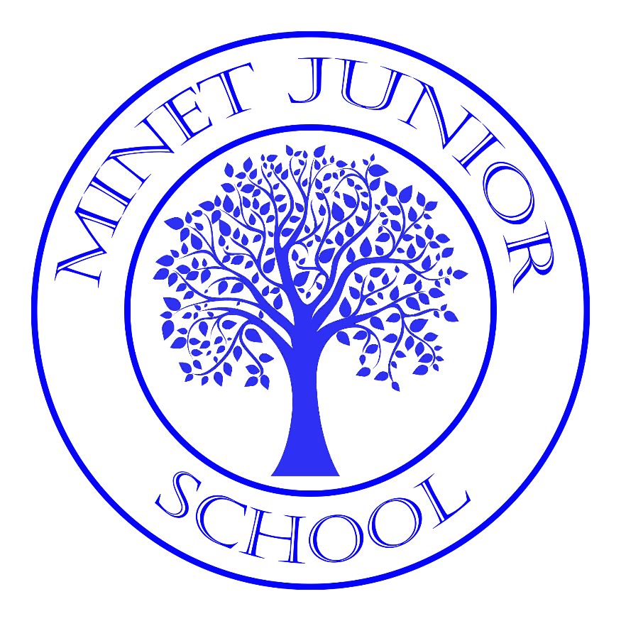

Completed by D Molloy
2023 - 2024

Aims
1. Produce creative work, exploring their ideas and recording their experiences
2. Become proficient in drawing, painting, sculpture and other art, craft and design techniques
3. Evaluate and analyse creative works using the language of art, craft and design
4. Know about great artists, craft makers and designers, and understand the historical and cultural development of their art forms.
Intent
At Minet Junior School our Art curriculum aims to inspire and challenge pupils, whilst equipping them with the knowledge and skills to be able to experiment, invent and create their own works of art. Children are given opportunities to explore and evaluate Artists and communicate what they see, feel and think through the use of colour, texture, form and pattern. As pupils progress, they should gain a deeper understanding of how Art and Design reflects and shapes our history, and how it contributes to the culture, creativity and wealth of our world. We want our children to use the local area as inspiration, to learn from other cultures and to respect diversity.
Implementation
The teaching and implementation of the Art and Design Curriculum at Minet Junior School is based on the National Curriculum and linked to topics to ensure a well-structured approach to this creative subject. Areas covered include: sculpting, printing, textiles and pointillism. The children's learning is further enhanced with whole school Art days where the children have the opportunity for collaborative working and exploring the different styles and techniques of a range of artists.
Impact
Ongoing assessments take place throughout the year. The children work towards an end of unit project. Whilst working towards completing their final piece, teachers use this information to inform future lessons and ensure children are supported appropriately. This data is analysed on a termly basis to inform and address any trends or gaps in attainment.

The National Curriculum - Key Stage 2 Programme of Study
1. Understanding
Pupils should be taught to:
- Describe and make comparisons between their own work and that of others, e.g. after a visit to a gallery discuss the feelings and emotions present in the pictures or sculptures seen and develop their own imaginative artwork based on their ideas.
During which pupils should have opportunities to:
- Experiment with some of the methods and media used by artists, e.g. try out different ways of making a portrait in paint, pencil, clay or mixed media while looking at work by several artists.
- Examine a variety of art, craft and design from different periods, places and cultures; considering their purpose and intentions.

2. Making
Pupils should be taught to:
- Experiment with and apply the visual language of art, craft and design which include:
Line: long, short, heavy, light, wavy and straight.
Colour: mixing primary, secondary and tertiary, matching colours from observation, using colours expressively and recognising how colour can influence mood and make images change in perspective.
Pattern: natural, from other cultures, repeated.
Texture: rough and smooth textures made with a range of media.
Shape: from nature, man-made, imaginary and repeated.
Form: making three dimensional shapes, sculptures and carefully observed form in two dimensional pieces e.g. figure drawing and animation (flip books)
During which pupils should have the opportunities to:
- Plan and make objects, images and artefacts in two and three dimensions using various materials for a variety of purposes e.g. use paper or card to make constructions based on local sculpture.
- Use their experience and knowledge of different materials, tools and techniques experimentally and expressively e.g. experiment with different media before undertaking a project about pattern.
- Select materials and colours ang give reasons for their chice
- Use a variety of techniques to add effects, e.g. shadows, reflection, hatching and cross-hatching
- Use tools and materials to carve, add shape, add texture and pattern

3. Investigating
Pupils should be taught to:
- Select and record form observations, experience and imagination to investigate the natural and man-made environment and the world of the imagination, using a variety of methods, e.g. making a series of studies in a sketch book form observing a bridge.
During which pupils should have opportunities to:
- Organise reference materials and resources to develop ideas and themes, e.g. collecting information from the Internet, Library or local gallery
- Keep a sketchbook to record information and observations
SMSC
Social
- Art and Design frequently requires pupils to work collaboratively – developing cooperation and communication; children learn to deliver their thoughts about the artwork of others constructively. These social skills are further developed through the discussion of artwork, where pupils critique art based on how it conveys emotions, texture and many other aspects
Moral
- In addition to encouraging a mutual respect and the consideration for others’ work, pupils will also be frequently encouraged to consider the moral implications of the stories behind the range of paintings that they are shown during their topic. Teachers encourage pupils to investigate the history behind the scene and debate any issues, considering decisions and circumstances involved in time periods and events within the paintings.
Spiritual
- Art lessons develop children's aesthetic appreciation. In turn, Art evokes feelings of 'awe' and 'wonder', giving children the chance to reflect on nature, their environment and surroundings. Pupils will also study artists with a spiritual or religious theme as well as ethical issues raised by artists, such as War paintings.
Cultural
- All of the paintings from across the topic link with contextual themes involving various cultures and civilizations from around the world. This allows for investigation and leads to a greater understanding of different ways of life and a respect for a wide range of cultures.
British Values
Art delivers British values through promoting a sense of enjoyment and fascination in learning about the surrounding world. Art promotes tolerance through sharing ideas, creative responses and understanding of different cultures and styles within art. Pupils are encouraged to question and explore sensitive and controversial issues, whilst maintaining tolerance and respect for the views and beliefs of others. Pupils explore and discuss a wide range of views and techniques in art and British art is explored in all year groups.
Equal Opportunities
All pupils should benefit from art education. The art curriculum is designed to provide a structure in which individual pupils can strive for the highest levels possible for them. Art education provides opportunities to celebrate and explore works from different cultures from around the world. The art curriculum aims to make children familiar with artists of sexes, all ages and nationalities. In this way pupils are exposed to a wide range of art and have access to a rich education.
Staff Development
It is important that teachers feel confident and comfortable in their teaching of art and design. The school is committed to staff development. INSET or staff training should be organised if staff feel that there is an area where extra support is needed. Staff may ask for advice and be supported by the subject coordinator when needed.
Special Educational Needs
“Art is a means of education not bound by written or spoken language and enables pupils with special needs of all kinds to develop a capacity of self-expression.”
Art can aid in developing positive attitudes and promoting self-esteem in pupils. As with any pupil, the teacher’s task is to help the SEN pupil to experience success, satisfaction and achievement in art. For pupils with special needs it is necessary to look at a range of methods of support to enable them to achieve their full potential in art. All children should regard art as a pleasurable activity and a means of expression that provides satisfaction in the making and end result.
Assessment
Teachers will undertake continuous formative assessment via the monitoring and achievement of the skills underpinning art. Targets will be updated regularly in books to show their progression and summative assessments will be carried out at the end of each unit via the teacher assessment of objectives on target tracker.
Displays
Displays will be up to date and imaginative, reflecting a range of children’s work throughout the school. Displays should be creative and informative and may often ask questions to further pupil’s thinking and creativity. Pupil’s work should be labelled with their name and class and questions should be displayed that will encourage creative thinking and promote an interactive use of the display.

