Important Information
Plot
Jim Jarvis becomes orphaned in London during the Victoria-era and finds himself in the workhouse, begging on the street and earning a living with an unpleasant master. His search for safety and a better life keeps him moving on time and time again.

Themes
Bullying, Poverty, Hardship, Hunger, Life and Death, Education, Welfare, Being Orphaned.
Setting
The book is set mainly in 1860s London during a time when the population of England had doubled in 50 years. People came to the cities for work, often still ending up unemployed and homeless due to overcrowding and where sanitation and disease were serious problems.
Characters
Jim Jarvis | Protagonist – Orphaned boy living in London.
Jim’s mother | Jim’s mother dies leaving him orphaned.
Lizzie and Emily | Jim’s sisters whom he is separated from.
Rosie | Jim’s mother’s only friend.
Tip | A friend Jim makes in the workhouse.
Mr Barrack | The harsh teacher in the workhouse.
Mr Sissons | The cruel master of the workhouse
Shrimps | A homeless boy who becomes Jim’s friend.
Grimy Nick | Antagonist - Jim is sold to the captain of a small coal ferry.
Snipe | Grimy Nicks aggressive dog.
Madame Juglini | Provides Jim with a job at the circus.
Dr Barnardo | After seeing the poverty and struggle of street children, he sets up a home for destitute boys.
Key Vocabulary
pauper | a very poor person
coaxed | to be persuaded or lured in
vaguely | uncertain, unclear or roughly
gruel | a thin, water porridge
infirmary | a place to care for the ill or dying
cholera | infectious, often fatal disease passed on through dirty drinking water. Many died of this in Victorian times.
scullery | a room joined to a kitchen
bramble | a prickly bush or shrub
taut | pulled or drawn tightly
lumber | to move with heavy clumsiness
caper | to dance or leap about playfully
skulking | moving around sneakily
wharf | a structure on the bank of a river to dock boats
reproach | to blame
workhouse | those unable to support themselves would work and be fed here. Treatment was harsh and unpleasant.
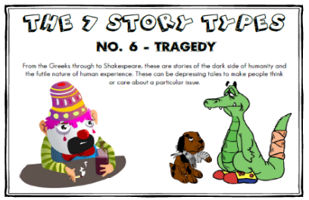
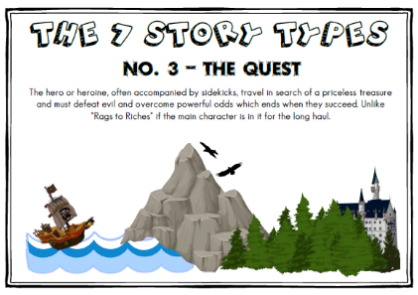
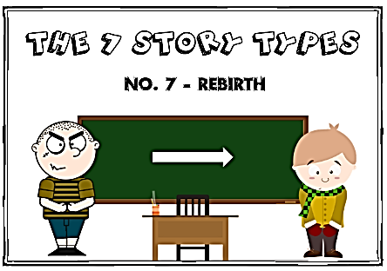
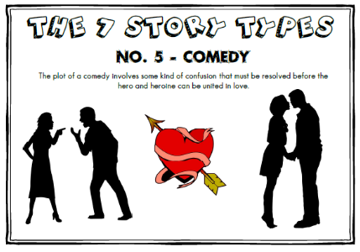
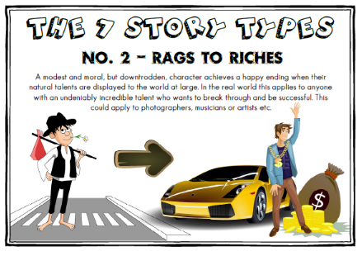
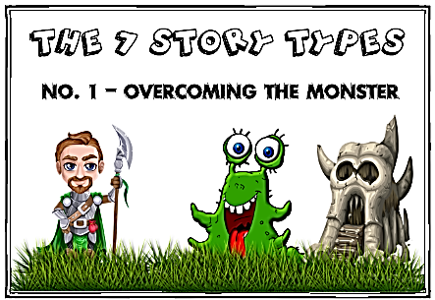

Context – The Victorian-era was defined by many things: Queen Victoria’s reign of the British Empire, famous inventions from the telephone to the railways, unusual medical practices. and medical advances and the significant gap between the rich and the poor. The introduction of the Education Act of 1870 meant children could finally attend school and the abolishment of children in workhouses did not occur until the early 1900s. Jim Jarvis was a real boy, but not very much is known about him. His story and that of other orphans was written down in a series of very short leaflets which Doctor Barnardo sent to wealthy people when he was trying to raise money to open an orphanage.

Name of Book: Street Child
Date Published: 1993
Author: Berlie Doherty
Genre: Historical Fiction

Book Knowledge Organiser – Street Child by Berlie Doherty

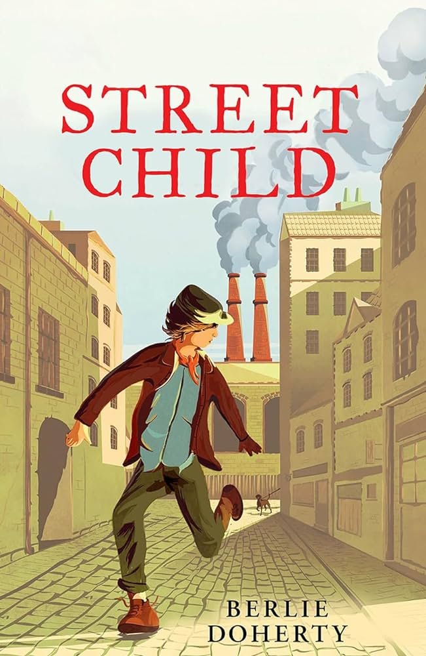
What Can the Book Teach Us?
Have perseverance and the hope for something better.
Our current way of life should be appreciated.
Not all adults are kind and generous.
Quotes
“No bars on the windows or locks on the doors. No beatings. I could run away tomorrow if I wanted to. But I don’t, see?”

