Guide for Students

Logging in
- Go to https://www.microsoft.com/en-gb/microsoft-365/microsoft-teams/group-chat-software.
- Click on ‘Use the web app instead’ link. You don’t need to get the window app.

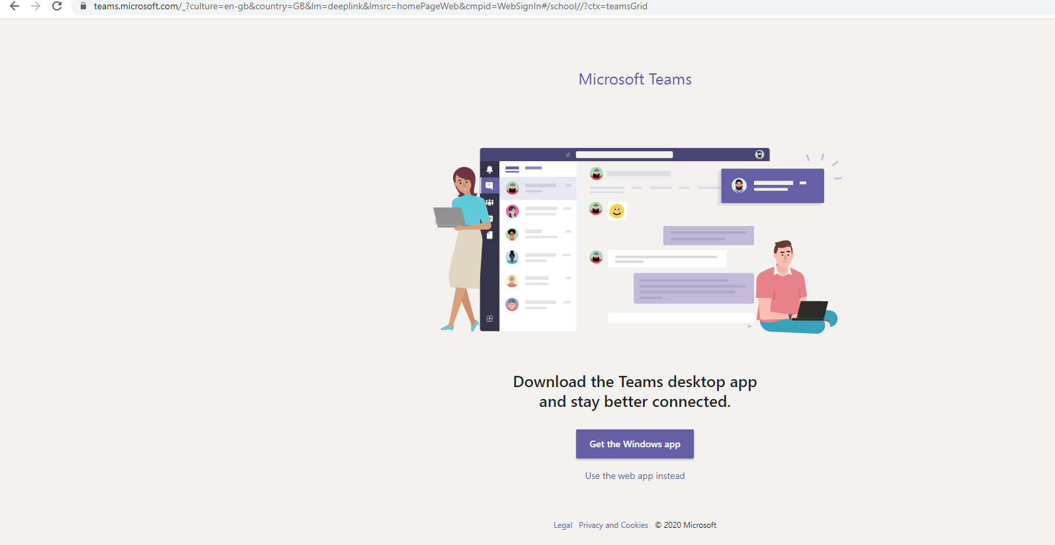

- Click on the ‘Sign in’ button. A Sign in box will appear.

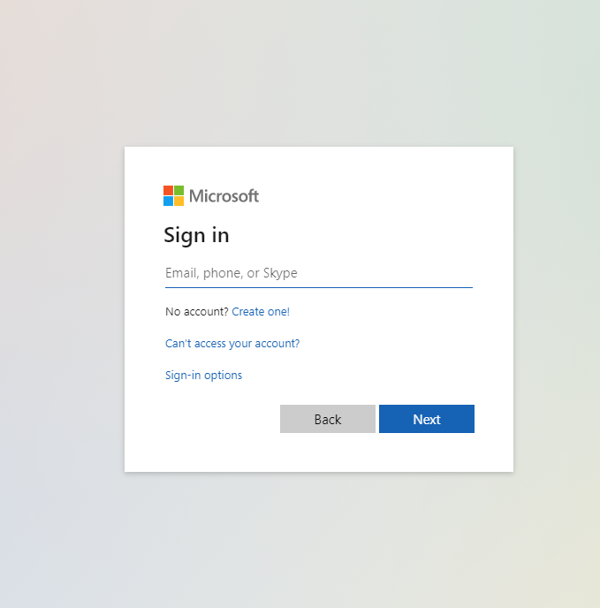

- Enter your email address provided by the school. xxxx@o365.minetjunior.org.uk.
- Enter your password.
- You are now logged in to your account.

Accessing your homework
- Once logged in, you will see this interface. This shows the team you are a member of. Click on your class Team Tile ‘5R’.

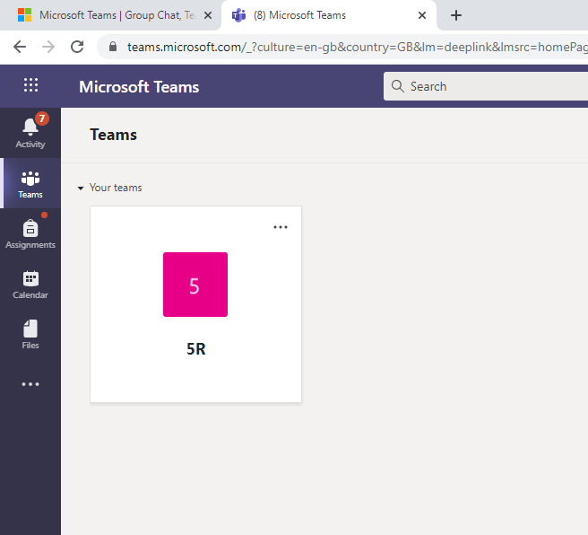

- Click on the ‘Assignment’ link on the left-hand side of the panel.

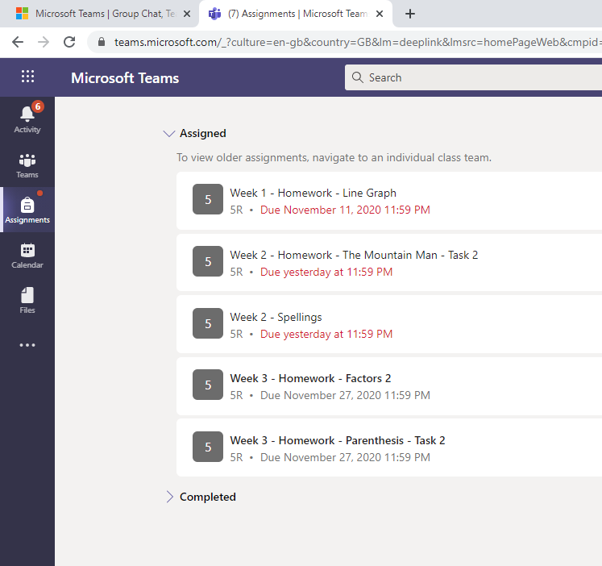

- Click on the assignment you would like to do.

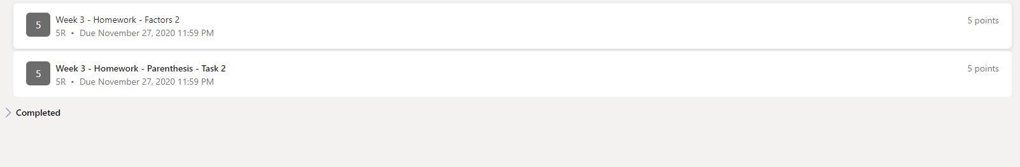

- Details of your assignment will appear.

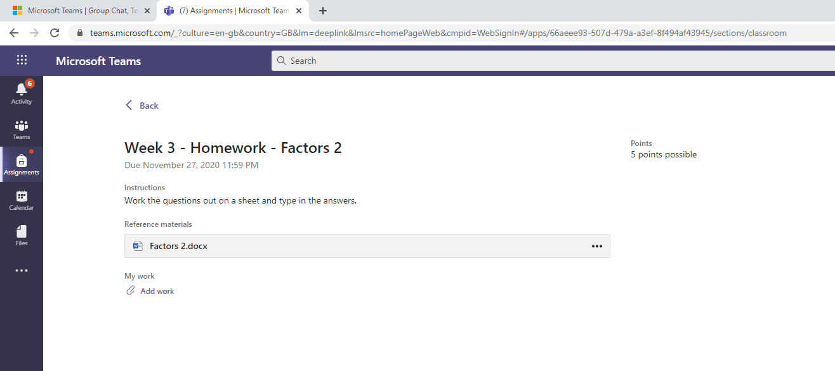

- You can access your homework sheet simply by clicking on the file name. Otherwise, click on the three dots on the right-hand side of the panel showing your assignment file name. A drop down will appear.

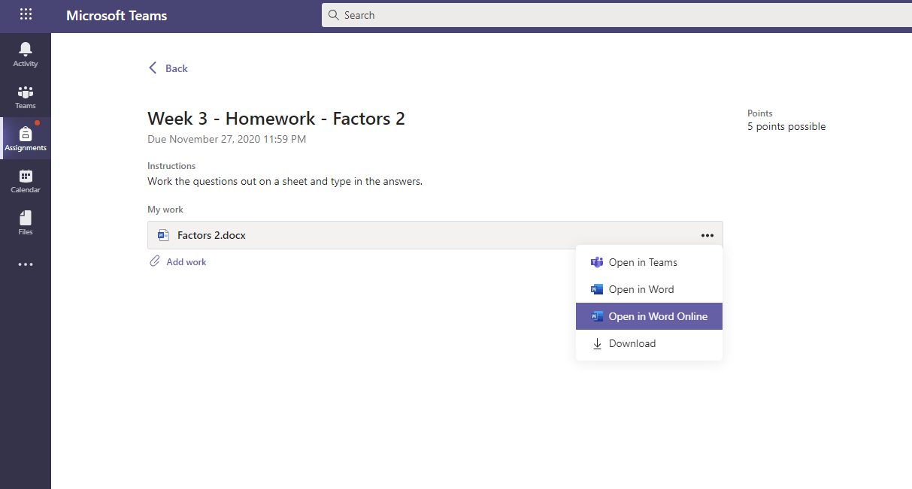

- Click on ‘Open in Word Online’. Your assignment will open and you will be able to complete the sheet. Your work will be saved automatically.
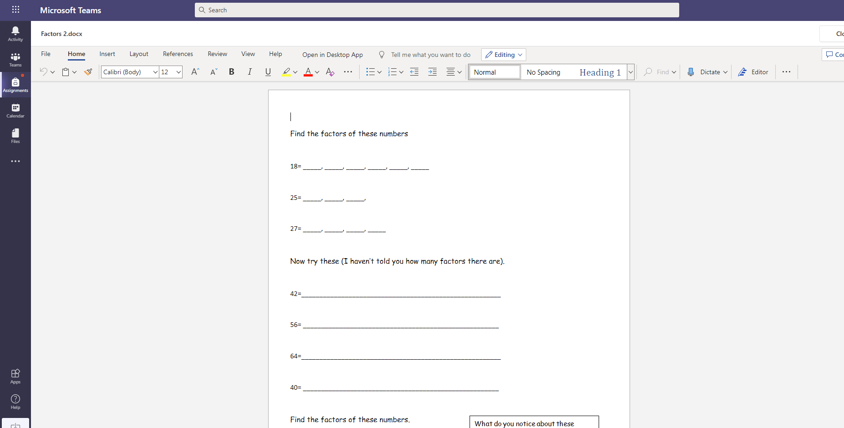

- After completing your task click on the ‘Close’ button on the top right hand side of the screen.
Tip: Open the file once more just to make sure that your work is saved and then close again.

- Click on the purple coloured ‘Turn in’ button on the top right corner. Your assignment will be sent to your teacher.

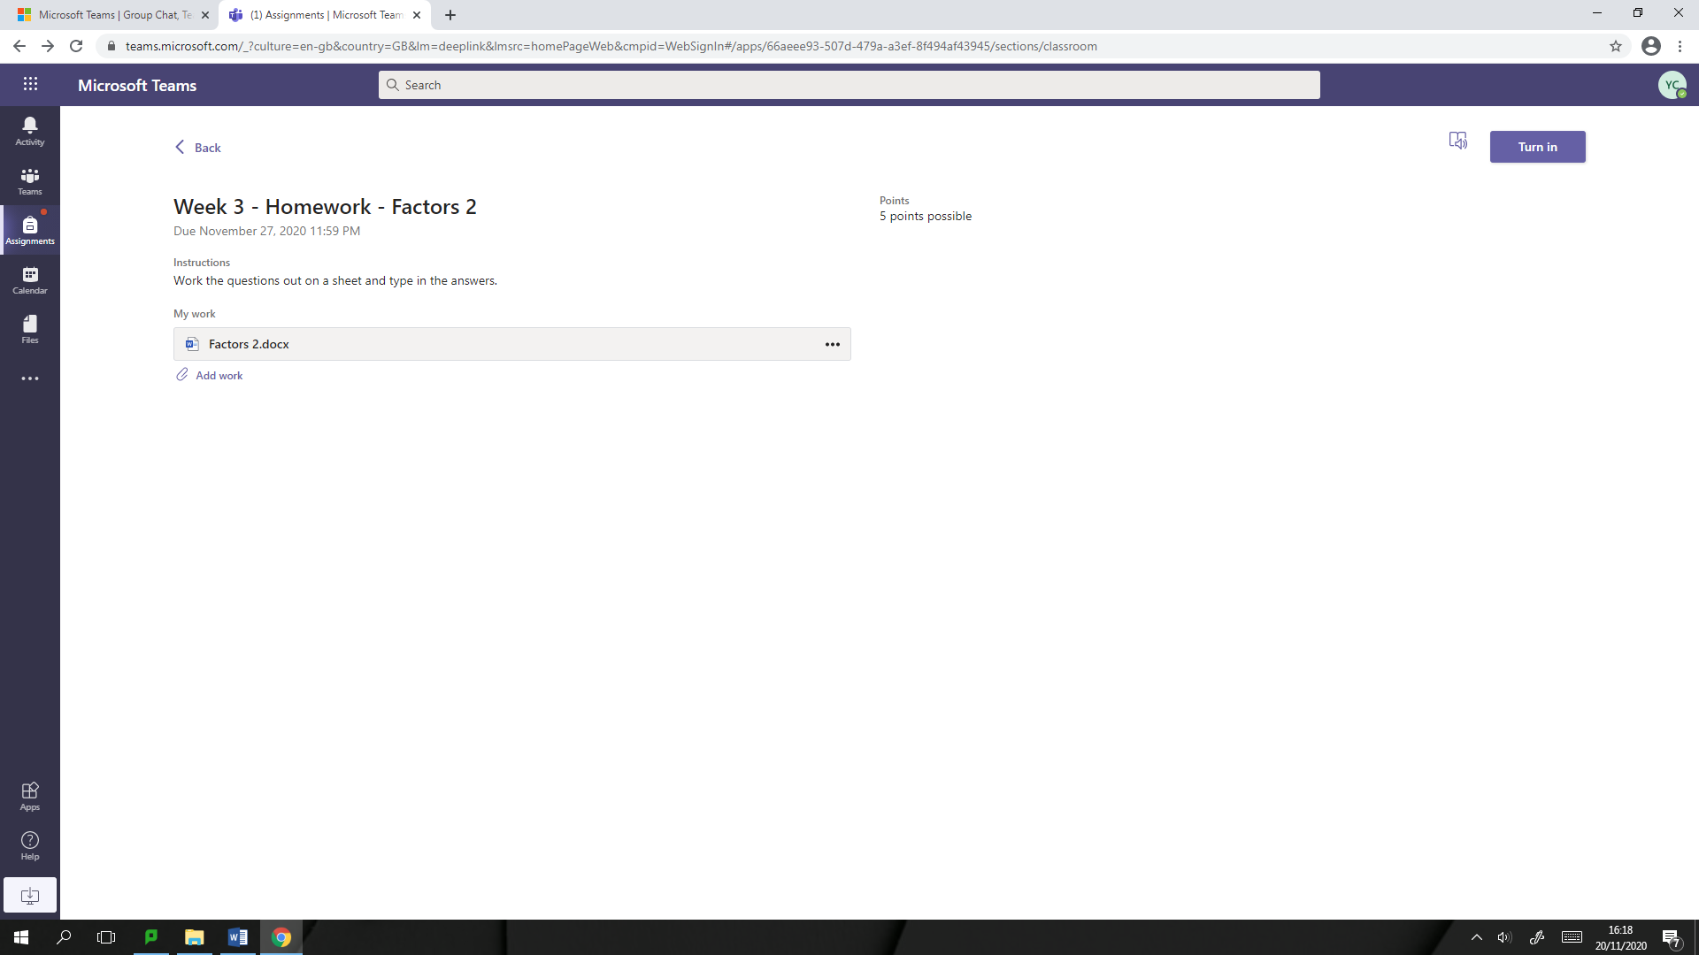

Troubleshooting -I am unable to write on my sheet.
There are three ways you can still turn your homework in.
- Method 1 - Download your homework sheet
- Follow steps 1-5 of ‘Accessing you Homework’ guide. Instead of clicking on ‘Open in Word Online’, click on ‘Download’.
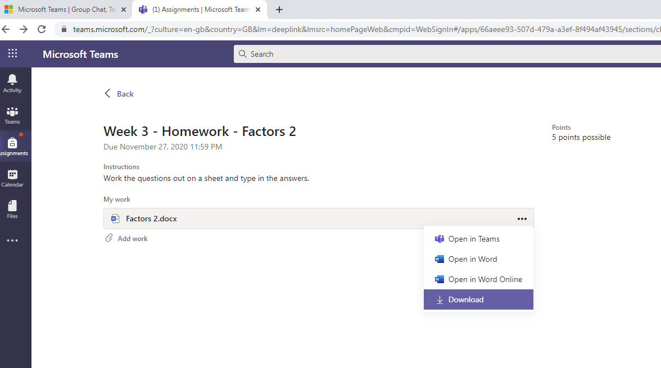

- Your file will start to download and will appear at the bottom left of your screen.

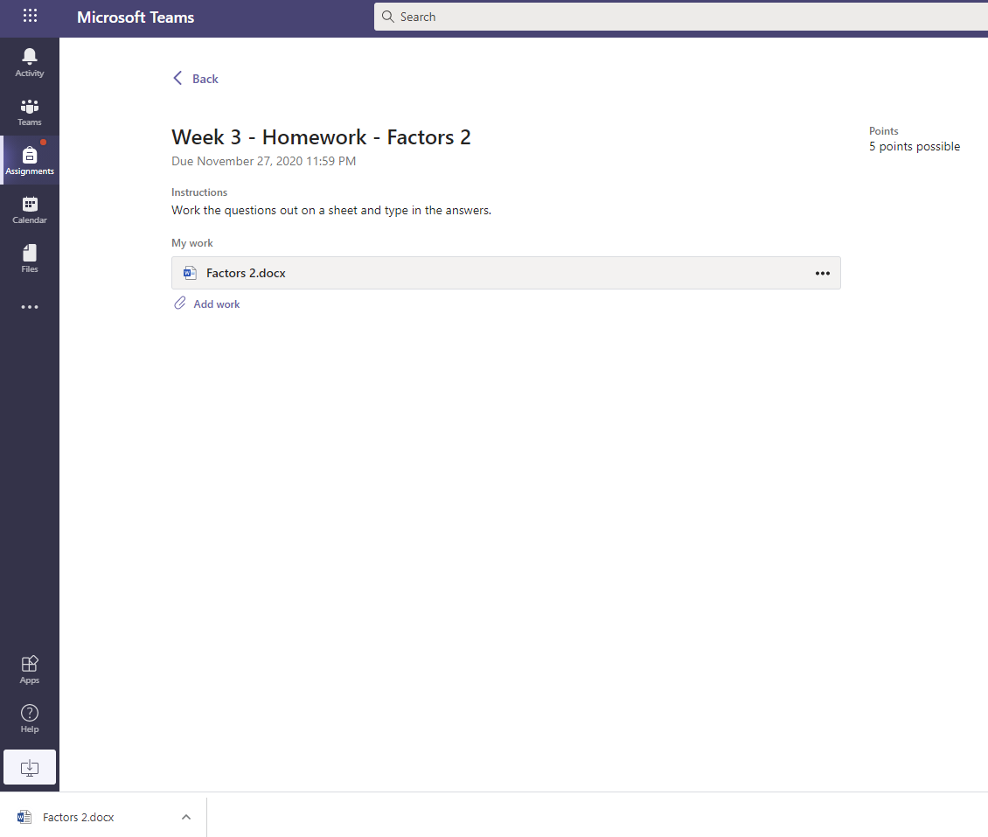

- Click on it. Your homework file will open in word.
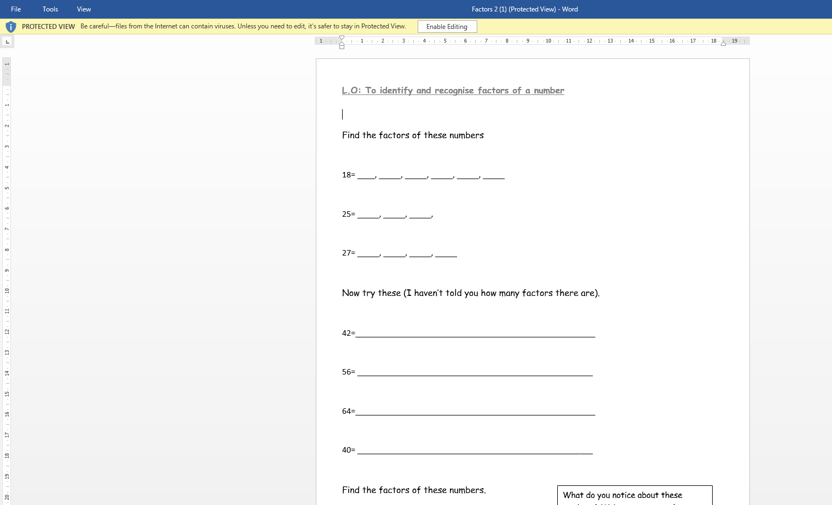
- Click on ‘Enable Editing’ button.
- Save this worksheet in your computer/Laptop.
- Complete your worksheet.

- Once completed, click on ‘Add work’.

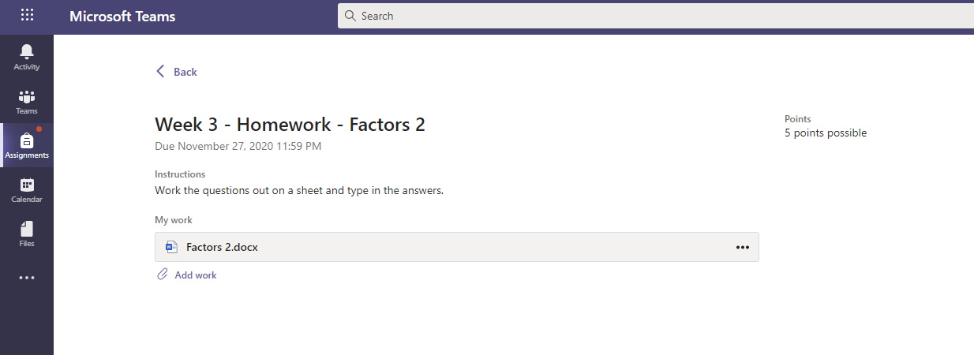

- A window will appear. Click on ‘Upload from this device’. Choose the file and click ‘Done’.
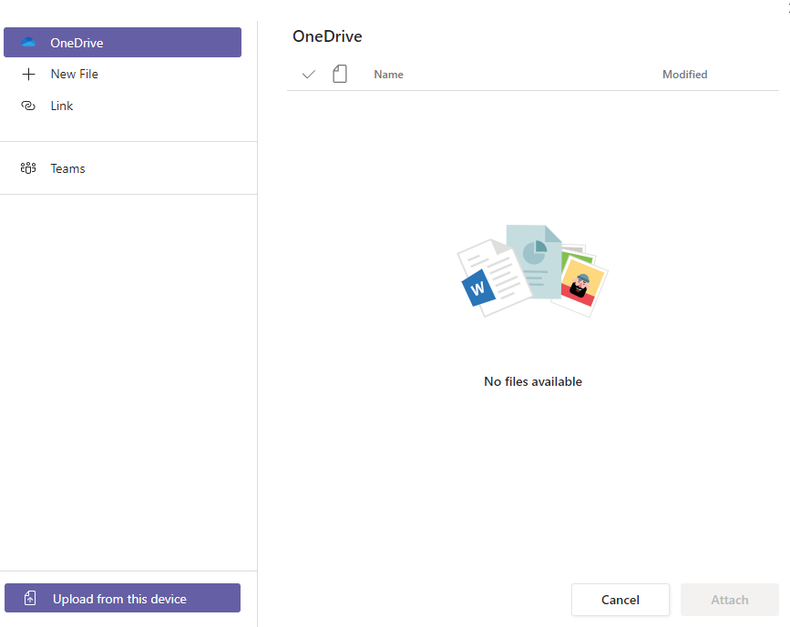
- Click on ‘Turn in’. Your teacher will receive your homework.

- Method 2 - Create a local file and type in your answers.

Go to your local drive. Right-click to create a folder. Say ‘Homework’.

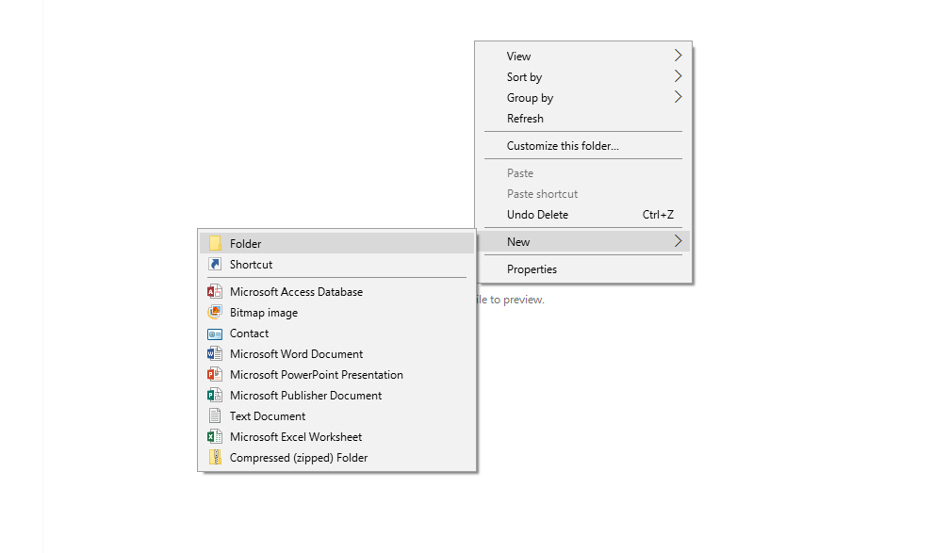

Click on this Folder. Right-click to create a Microsoft Word file.

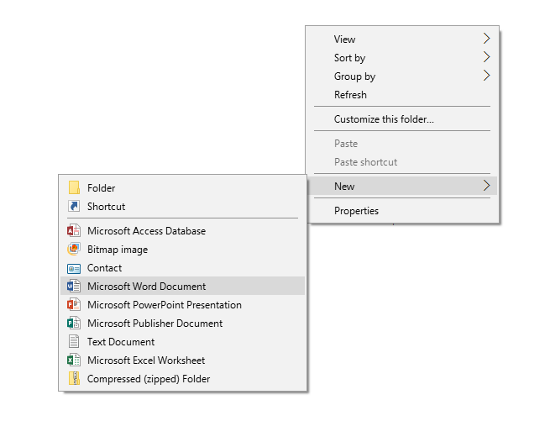

Name this file. Say ‘Week 3_Maths’.

Write down the answers in the word document. Make sure to number them same as the worksheet. Follow steps 7-9 of Method 1 to submit your homework.

- Method 3 - Do your home on a piece of paper and upload it.
Complete your home on a piece of paper. Take a picture on a phone. Ask an adult to email it themselves. Save the file on the system. Follow steps 7-9 of Method 1 to submit your homework.

