Important Information
Plot:
The Stone Age Boy is a story about a young boy who mysteriously finds himself transported back in time to the Stone Age. He meets Om, a girl from the past, who is part of a small Stone Age tribe. Together, they experience life in the Stone Age, learning about how people lived, what tools they used, and how they hunted and gathered food. The boy from the future learns how different the past way from his own time, and the story explore friendship, survival, and how we adapt to different environments.
Themes:
Time travel and exploration, friendship, survival in the Stone Age, learning about the past.
Setting:
Prehistoric time in the Stone Age
Characters
The Modern Boy: | The main character who finds himself in the Stone Age. He is curious and learns many new things about the past.
Om: | A girl who lives in the Stone Age. She teaches the modern boy about life in prehistoric times, including hunting, gathering and survival skills.
The Tribe | Other members of the Stone Age community that the boy meets, including adults and children. They help the boy understand their way of life.
Context:
One day a little boy is walking along when he trips, stumbles and falls… into the Stone Age. He meets a girl his own age, along with her tribe, and learns all about their way of life. He watches them make tools, clothes and weapons. He sees how they hunt, fish, cook, celebrate – and even how they paint on the walls of caves.

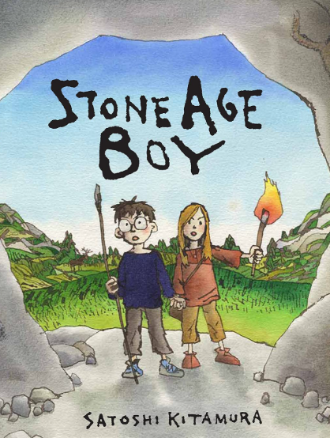
Book Knowledge Organiser – Stone Age Boy

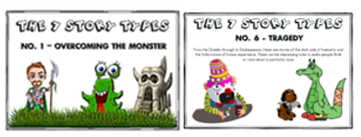
What Can the Book Teach Us?
The Stone Age Boy teaches lessons about the past, the values of teamwork, the importance of adapting to new situations and how curiosity and learning shape our understanding of the world.

Quotes

“She took me to meet her family – and what a family it was!”

“Years passed, but I never forgot my friend Om.”

 | Key Vocabulary
Stone Age: | A prehistoric period when humans used stone tools and lived in caves.
Prehistoric: | Refers to the time before written history.
Tribe: | A group of people, often with a shared culture and language, who live together.
Cave: | A natural underground space where some Stone Age people lived.
Hunter – gatherer: | People who hunt animals and gather plants for food rather than farming.
Flint: | A hard type of stone used to make tools in the Stone Age.
Title: The Stone Age Boy
Author/Illustrator: Satoshi Kitamura
Genre: Fiction (Adventure)
Published: October 2007

