Minet Junior School

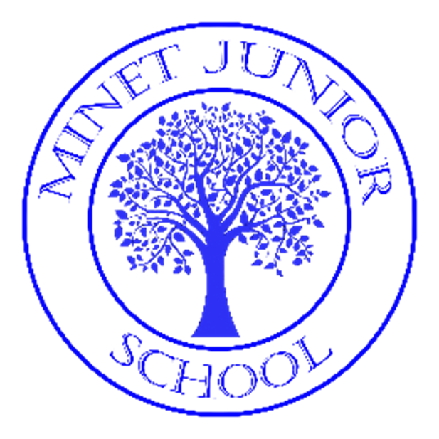

Reading Policy 2023
Up-dated by
L Cooper
(Reading Co-ordinator)

What is our intent?

At Minet Junior School, reading is a top priority and is a key driver in our curriculum, which has been adapted to meet the needs of our diverse intake of children. Our Reading intent is to ensure our children transition to high school as confident, fluent readers who have a passion for reading (beyond the National Curriculum) and who have lifelong positive attitudes towards reading.

Reading is a fundamental part of our school, as it is a skill which underpins a child’s ability to access the wider curriculum. It allows them to broaden their vocabulary, develop their vivid imaginations and prepare them for the wider world.

We aim to provide our children with a literacy-rich environment, high-quality texts and inspiring learning opportunities, which will help them to:
- To read independently, fluently and expressively, with understanding, enjoyment and confidence.
- To foster an enthusiasm and love of reading for life.
- To understand what they have read and link it to their own lives and experiences, developing a deeper level of emotional intelligence.
- To understand the link between reading and writing and apply techniques discovered in their reading and writing.
- To create a language rich environment that will support pupils in their reading and writing.
- To develop comprehension skills of inference and deduction.
- To talk confidently about their reading.
- To apply a knowledge of structured synthetic phonics (phonic, graphic, syntactic, contextual) to decode unfamiliar words with increasing accuracy and speed.
Reading and Phonics is a high priority to address gaps because of deprivation and cultural diversity, which will feed into all areas of the curriculum.

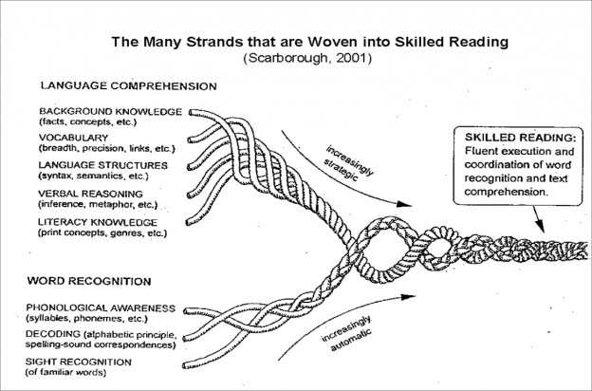
How is it implemented?
At Minet Junior School, we deliver our Reading curriculum through a variety of ways to provide the children with frequent opportunities to develop their reading. We teach daily guided reading lessons, which are adapted to engage and enthuse our children from a range of diversities, as well as regular whole class reading within our English lessons. In addition, we allocate time within our timetable for the children to read a book of their choosing independently, as well as time in the day when the teacher reads the children their chosen class book, giving children time to listen and enjoy a book being read to them.
For those children who require further support with their reading, we use ECAR (Every Child A Reader) for children working below their reading age and also run daily Read Write Inc classes for our EAL children who need further support. We continually monitor our children’s development with regular 1:1 reading sessions using banded books, which are also used as home reading books. This is then monitored online and we provide parents with Bloom’s Taxonomy questions stems to support reading at home. In addition to this, we also provide numerous opportunities for reading in other areas of the curriculum, allowing the children to develop their thirst for reading, improve their vocabulary and further develop their comprehension skills through cross-curricular reading.

Teaching and learning
We teach much of the programme of study for reading through English lessons and daily whole class guided reading lessons that use high-quality texts. The teaching and learning of reading are a top priority at Minet Junior school and to ensure that we give pupils the best opportunity to succeed, we teach daily reading to build upon and develop skills in fluency and comprehension.
At Minet, we have developed a purposeful, whole class reading approach that equips pupils with the necessary skills to be successful readers. It focuses on building fluency and embedding comprehension skills with lessons linked to the assessed strands at the end of key stage assessments (the content domains).
Content Domains
The content domains are statements that break down the approach to reading into elements in which the children should become skilled. They explore background knowledge, vocabulary, language structures, literacy knowledge and word recognition, which will ensure that our children develop a clear understanding of the different aspects of reading. Each key domain has an image associated with it so that children can make links and, as they become confident in understanding each key domain, they can identify which skills to use. Using the seven content domains as an underlying approach ensures that children have skills that last beyond school.

 |  |  |  |  |  | 
Vocabulary Victor  (2a) | Rex  Retriever  (2b) | Summarising Sheba  (2c) | Inference Iggy  (2d) | Predicting Pip  (2e) | Cassie Commentator (2f) & (2h) | Arlo the  Author  (2g)
Give / explain the meaning of words in context | Retrieve and record information / identify key details from fiction and non-fiction | Summarise main ideas from more than one paragraph | Make inferences from the text / explain and justify inferences with evidence from the text | Predict what might happen from details stated and implied | Identify / explain how information / narrative content is related and contributes to meaning as a whole.  Make comparisons within the text. | Identify / explain how meaning is enhanced through choice of words and phrases.

The teaching of phonics
To bridge the transition from Infant to Junior School, Year 3 will be continuing the teaching of phonics and ensuring the children are able to decode words. To do this they will work on a rolling, flexible timetable which revolves around setting. After the initial phonics screening, the children will be set and taught phonics before moving to following the whole class guided reading scheme by the Summer term with additional interventions put in place for those that still need support.
See phonics policy
 | Autumn | Spring | Summer
LA | Set phonics | Set phonics and reading skills | Whole class guided reading and phonics
MA | Set phonics | Pearsons’s intervention – whole class approach | Whole class guided reading and spelling rules
HA | Whole class guided reading and spelling rules | Whole class guided reading and spelling rules | Whole class guided reading and spelling rules

Whole Class Guided Reading
The whole class reading approach supports rapid progress of lower ability readers and research suggests this is due to exposure to higher level texts and discussions. Each week, the children study an extract taken from a text that relates to their curriculum focus for that term. This provides opportunities for more in-depth exploration, a collection of vocabulary to widen their knowledge and an opportunity to make cross-curricular links. The chosen, age-appropriate extracts cover a range of genre, with at least one week every half term being dedicated to poetry and one to non-fiction. The extracts are then used to structure a weekly plan that relates to the teaching of the seven key contain domains.
Weekly planning overview
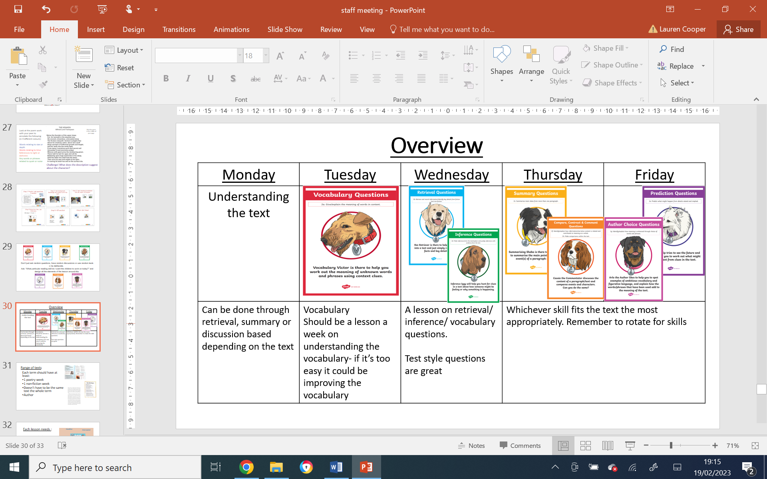
During a typical lesson, the teacher will begin by sharing the learning objective, content domain and success criteria that the children will focus on. There are many opportunities for reading during the lessons: they will hear the teacher model fluent reading, they have time to read independently, they could re-read the text having listened to the teacher’s model and they could read to their peers in partner talk. Several of these different strategies may be used during any one session.
Once familiar with the text, the teacher will then move on to the teaching of the chosen content domain for that day (see table above) where, through planned key questions, the children are encouraged to discuss their ideas as a class, in groups or in pairs before writing so that they have time to gather ideas, reflect and provide quality answers. Within the whole class reading lesson, there are also opportunities for the teacher to model how to write an answer to the question being asked. This enables pupils to have exposure to high-quality modelling –where language, structural and organisational techniques are taught. We then encourage the children to, where appropriate, provide answers that provide evidence from a range of different places within the text using the ‘Point, Evidence, Explanation’ model.
During the lesson, the activities and level of support are adapted for different abilities so that all children can access the learning objective. For example, some children may receive sentence stems to help them answer questions or they may be given a pictorial stimulus. In addition to this, further ‘Dive Deeper’ activities are also available for those working at an advanced level. Each child has their own guided reading book to record any work they undertake and this is monitored and marked by the class teacher. (See Marking Policy)

Individualised Reading
In September and February of each year, we assess children using the ‘Suffolk Reading Test’ which provides the teacher with a reading age for each child. Teachers will use this assessment, along with formative assessments, to allocate a reading book colour band to each child according to their individual needs. Pupil’s progress through the colour-coded scheme books at their own individual pace, reading at home with parental support, until they eventually become ‘free readers’. Teachers track independent reading and discuss progress with individual pupils regularly. When needed to be changed, the children select their own books and are encouraged to read widely across genres.
Intervention programmes
Intervention programmes are used in all year groups to support pupils as needed. This can include: pupils who have made insufficient progress, pupils who are not working at an age-expected level, pupils who have had extended period of absences, pupils who have struggled to grasp a new concept, children with IEPs or other identified pupils who need additional support in Reading.
Intervention programmes may be taught by a teaching assistant or the class teacher. During guided reading lessons, all year groups currently run the ECAR (Every Child A Reader) intervention for children working at a CUSP or just below their expected reading age. The scheme focuses on the reptetition of contain domains skills and provides texts at age-appropriate levels.
Other interventions include Read/Write Inc., reading comprehension sessions, phonics interventions and booster lessons.

English as an Additional Language
On the arrival of a child with an EAL need, they are assessed and placed in a Read Write Inc group, with a specialised teacher, that focuses on the excelled teaching of phonics. Staff liaise with parents to encourage them to enjoy bilingual books with their children: asking questions and discussing the book in their home language or in English and supporting their enjoyment of books and their acquisition of English.


Parental Engagement
Our parents are encouraged to read daily with their child for fifteen minutes each night. Each child has a log-on for ‘Boom Reader’ –an online programme that monitors reading a child’s home reading journey- which is checked daily by teachers as it is used as a dialogue between teachers and parents. Parents may comment on their child’s reading and teachers keep parents updated on reading progress within the school. Once a child has completed their book, they will be allocated a new one in line with their reading age. In addition to this, the children are set books on ‘Bug Club’ which provides age related texts and comprehension questions.

Reading for pleasure
Children at Minet Junior School experience a rich curriculum that encourages a love of literature. All classes have a ‘class read’ which is a high-quality text that often relates to their current curriculum topic. We encourage our pupils to reflect on what they have read and to share and justify their opinions. We believe that active encouragement of reading for pleasure is a core part of every child's educational entitlement because we know that extensive reading and exposure to a wide range of texts contributes hugely to our pupils' educational achievement. Throughout the year, we plan events to promote reading for pleasure in the school community. These events include world Book Day activities, visits from authors, visits to the local library and competitions.

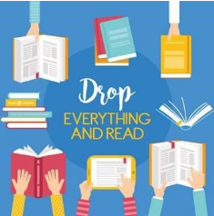
D.E.A.R (Drop Everything and Read)
At Minet, we run Drop Everything and Read. For ten minutes every day, usually after lunch, everyone in the class (teachers included) reads a book of their choosing for ten minutes. Including the teachers in this activity models the importance of reading for pleasure within the school. Children have the rights of the reader during this time and can change their book if they’re not enjoying it, re-read books and discuss what they’re reading with their peers.
Learning Environment
Each class has a reading area/book corner which provides a stimulating and attractive environment and contains a range of reading material. Reading areas may often share links and work related to the class topic and key text. This can include:
• A wide variety of fiction and non-fiction books
• Newspapers, comics and magazines
• Books which link to the genre being covered in literacy
• Picture books
• Recommended reads – recommendations made by teachers, teaching assistants and
pupils.
Books are organised into non-fiction, fiction and poetry and be easily accessible by the children.
Children should be actively involved in the management of the reading corner.

Equal Opportunities
Minet Junior School has universal ambitions for every child, whatever their background or circumstances. Children learn and thrive when they are healthy, safe and engaged. In order to engage all children, cultural diversity, home languages, gender and religious beliefs are all celebrated. Our curriculum includes a wide range of texts and other resources which represent the diversity and backgrounds of all our children. We believe in, ‘valuing what the child brings to school’ and recognise the importance of supporting a child’s first language, not only to foster self-esteem, but to assist in the learning of English. (Please see the ‘Equal Opportunities Policy’).

SMSC
Spiritual – Developing deep thinking skills so that children can question the way the world works.
Moral – Providing literature which leads to opportunities to discuss ‘right and wrong’.
Social – Opportunities to comment and debate. Talk partners encourage discussion.
Cultural – Ensuring children are given opportunities to share their experiences, enabling children to explore different cultures and make comparisons.

How is the impact monitored?
By the end of their time at Minet Junior School, children will be confident readers who are reading at an age appropriate level. We believe that reading is the key to all learning and that the impact of our reading curriculum goes beyond the results of statutory assessments. As they move through the school, children develop their fluency and comprehension whilst accessing a range of texts with support and independently. Our teacher assessments and termly standardised tests allow us to measure individual progress and attainment. Our pupil progress meetings allow us to identify and implement additional support for those that need it. When they leave us, we want children to possess the reading skills and love of literature that will help them enjoy and access any aspects of learning they encounter in the future.

Tracking Progress and Attainment (see also Assessment Policy)
Teachers track pupils’ progress during each lesson and assess and monitor targets regularly. This information is used to inform teacher judgements on target tracker (the school’s online assessment tool). Children will also take tests throughout the year to assess their reading and comprehension levels, which are also used to inform teacher judgments (See timetable). Reading attainment and progress is monitored termly and discussed with the SLT during pupil progress meetings. Reading progress is also discussed and monitored regularly by the reading Co-ordinator.

 | Autumn 1 | Autumn 2 | Spring 1 | Spring 2 | Summer 1 | Summer 2
Year 3 | Phonics screening  NFER Baseline test | NFER  Test  Phonics screening |  | NFER  test |  | NFER  Test
Year 3 |  |  |  | Phonics screening- for selected children |  | Phonics screening- for selected children
Year  4 & 5 |  | NFER  test |  | NFER  test |  | NFER  test
Year 6 | Year 6  Past SATS | Year 6  Past SATS | Year 6  Past SATS | Year 6  Past SATS | SATS | Judgement to be made using the Interim Teacher Assessment Framework
All | Suffolk Reading Test |  |  | Suffolk Reading Test

