Important Information
Plot:
Naledi and Tiro’s baby sister is ill but their mother works over 300km away in Johannesburg. They decide to leave their village and walk all the way to bring her back. Along the way they meet people who help them and others who frighten them. They also learn about what is really happening in their country.
Themes:
Rebellion, Family, Life and Death, Perseverance, Friendship, Courage, Government, Apartheid, Rich and Poor and Injustice.
Setting:
The book is initially set in the flat grassland of a village in South Africa. The children travel over 300km to the large urban city of Johannesburg, past mountains, orange farms and over dry red earth. They stay in nearby Soweto, known for being a dangerous city, until they travel to an overcrowded and poorly maintained hospital.
Characters
Naledi | Young girl who decides to travel to Johannesburg to inform her mother that Dineo (her baby sister) is sick and needs help. She is Tiro’s sister
Tiro | Young boy who decides to travel to Johannesburg to inform his mother that Dineo (her baby sister) is sick and needs help. He is Naledi’s brother
Dineo | Little baby sister of Naledi and Tiro who is sick and needs treatment.
Nono | Naledi and Tiro’s granny
Mmangwane | Naledi and Tiro’s aunt.
Mma | Mother of Naledi, Tiro and baby Dineo who works in Johannesburg.
Poleng | Naledi’s friend who says she will help their granny while they are away
Grace Mbatha | A young woman who lives in Soweto who offers help to the children
Pail and Jonas | Brothers of Grace who are interested in Naledi and Tiro’s adventures.
Dumi | Grace’s other brother who protested on the streets about education.
Context – Over 100 years ago, diamonds and gold were discovered in South Africa and Britain wanted the wealth. A war waged between Britain and Afrikaners whose ancestors were mainly Dutch. Black Africans, who were the majority, had no say in matters. When Britain won the war, they were in charge of taxing everyone and so black people were forced to work for white Europeans. In 1910, the British handed power to both the English and Afrikaners and they created the ‘Land Act’ which stopped black people from owning land, except in reserved areas. In 1948, when an Afrikaans-speaking government was elected, the racism in the country tightened and was called apartheid, separating racial groups in many ways: where you lived, what work you could do, whether you could go to school, which door you had to use to enter a building or whether you could play on a park. Much more money was spent by the government on white schools, white hospitals and white facilities. Nelson Mandela from the African National Congress wanted change but was put in prison in 1964. In 1976, young black students protested when the government forced them to learn lessons in Afrikaans. Many were killed as Naidoo and Tiro find out for themselves. The book was published in 1985 and originally banned from South Africa. Nelson Mandela was finally released in 1990, after the book’s release and, when all adults were given the right to vote, he became the president of South Africa, ending apartheid in 1994.

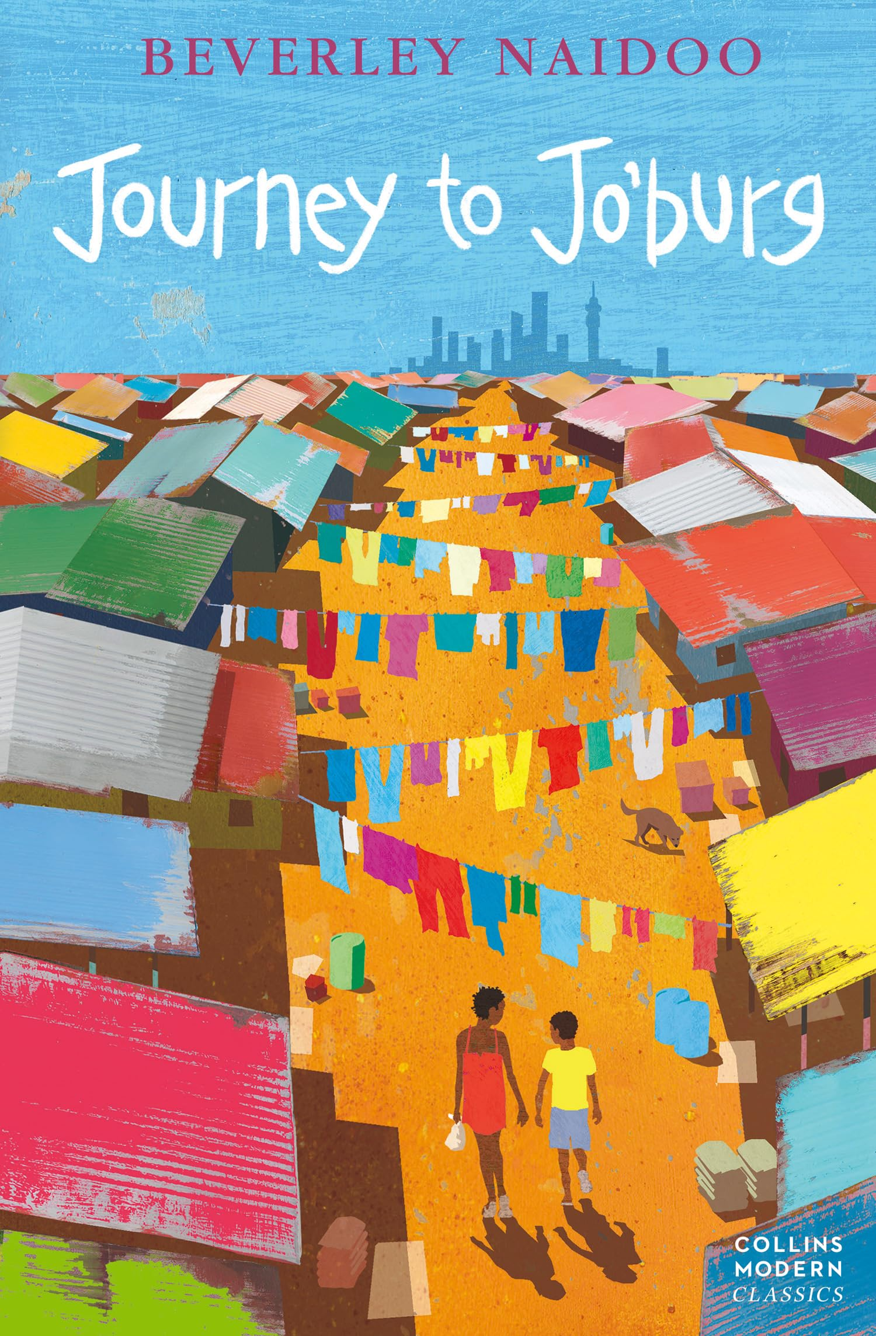
Title: Journey to Jo’burg
Author/Illustrator: Beverley Naidoo & Lisa Kopper
Genre: Fiction
Published: 1985

Book Knowledge Organiser – Journey to Jo’burg

 | Key Vocabulary
Bluntly | saying something without considering another’s feelings
Telegram | long-distance message sent electronically as code
Glinted | to give out or reflect small flashes of light
Clutched | to grasp something tightly
Farewells | used to express good wishes when leaving someone
Startled | feeling or showing sudden shock or alarm
Tswana | One of the official languages of South Africa
Inconvenient | being troublesome or difficult
Carriage | any of the separate sections of a train carrying passengers
Commotion | a state of confused and noisy disturbance
Protesting | an expression of disapproval or being against something
Loafer | a person who avoids work and wastes their time
Mudguard | curved strip or cover above a wheel of a vehicle
Government | the group of people who control / govern a country
Numbly | to do or say something with no feeling
Anxiously | to do or say something with a sense of worry
Obediently | willing to do as one is told and follow instructions
What Can the Book Teach Us?
Whole governments have had, and can still have, racist policies. Sometimes we are naïve to other people’s struggles. We must learn from the past so that we get the future right

Quotes
“You must be strangers here if you don’t know about the buses.” “Well Joyce, I can’t possibly let you go today.” “He had written FREEDOM in big letters.”

